Day 19 Practical Homework | Cycle 33*
Create virtual machine with onpremise sql server image

Creating resource virtual machine. Availability option – No Infrastructure required and Security type – Standard.

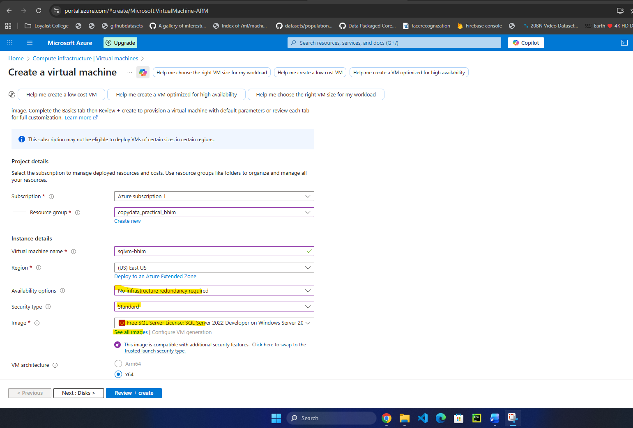

Selecting the SQL SERVER image with windows and selecting the free license (highlighted part)
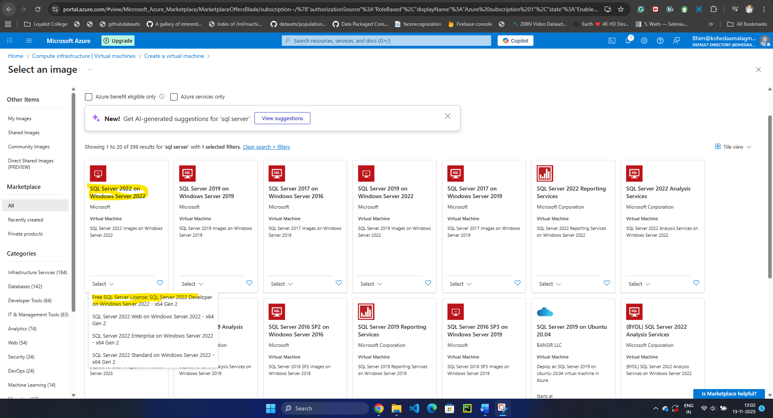
Selecting size – B2s with 4GB RAM. Setting up the username and password for VM.
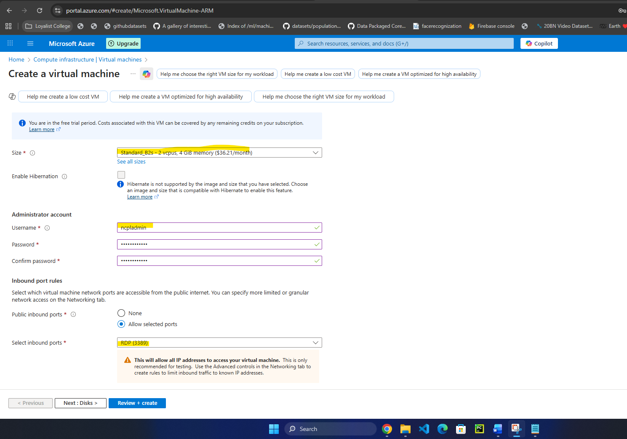

Enabled SQL authentication –
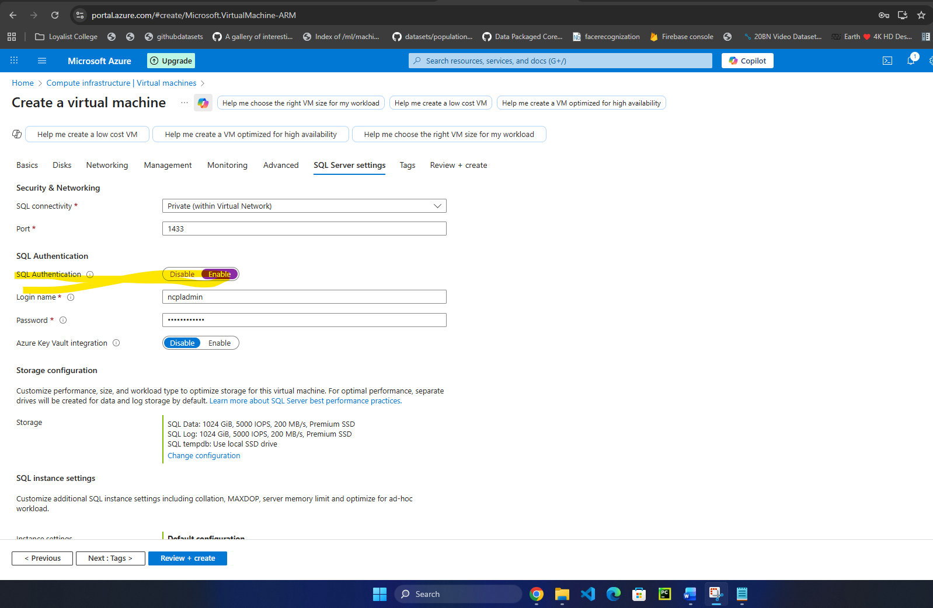

Successfully deployed the VM.

